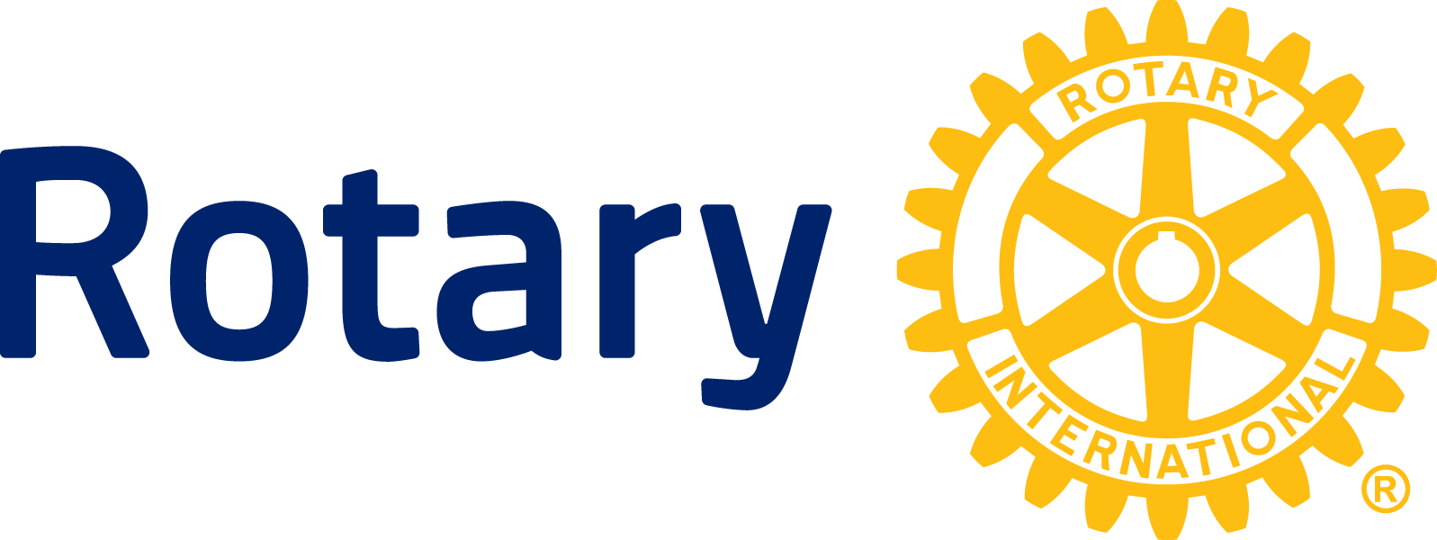

NEWS RELEASE

Rotary club of [insert name of town or city]
[insert verb and topic]

CITY, STATE (DATE) —

Lorem ipsum dolor sit amet, consectetur adipiscing elit, sed do eiusmod tempor incididunt ut labore et dolore magna aliqua. Cursus sit amet dictum sit. Nibh tortor id aliquet lectus proin nibh nisl condimentum. Metus dictum at tempor commodo ullamcorper.

Tellus rutrum tellus pellentesque eu tincidunt tortor aliquam nulla. Varius sit amet mattis vulputate enim. Hendrerit dolor magna eget est lorem ipsum. Enim nec dui nunc mattis enim ut tellus. Enim tortor at auctor urna nunc. Urna neque viverra justo nec ultrices dui sapien eget. Vitae justo eget magna fermentum iaculis eu non.

Venenatis lectus magna fringilla urna. Eu scelerisque felis imperdiet proin fermentum leo vel orci porta. Curabitur gravida arcu ac tortor. Interdum posuere lorem ipsum dolor sit amet. Amet consectetur adipiscing elit pellentesque. Eget arcu dictum varius duis at consectetur lorem donec. Cursus turpis massa tincidunt dui ut ornare lectus sit amet.

Tellus rutrum tellus pellentesque eu tincidunt tortor aliquam nulla. Varius sit amet mattis vulputate enim. Hendrerit dolor magna eget est lorem ipsum. Enim nec dui nunc mattis enim ut tellus. Enim tortor at auctor urna nunc.

About Rotary District 7620

Throughout Central Maryland and Washington, D.C., Rotary District 7620 brings together a network of volunteers dedicated to tackling the world’s most pressing humanitarian challenges. Rotary connects 1.2 million members of more than 35,000 Rotary clubs in over 200 countries and regions. Their work improves lives at both the local and international levels, from helping families in need in their own communities to working toward a polio-free world. For more information, visit Rotary7620.org.

###

Contact: zxzxz zxzxzxzx (phone/email)
ROTARY CLUB OF [CITY]

